- Program ID : VA002MA1

- Display Layout
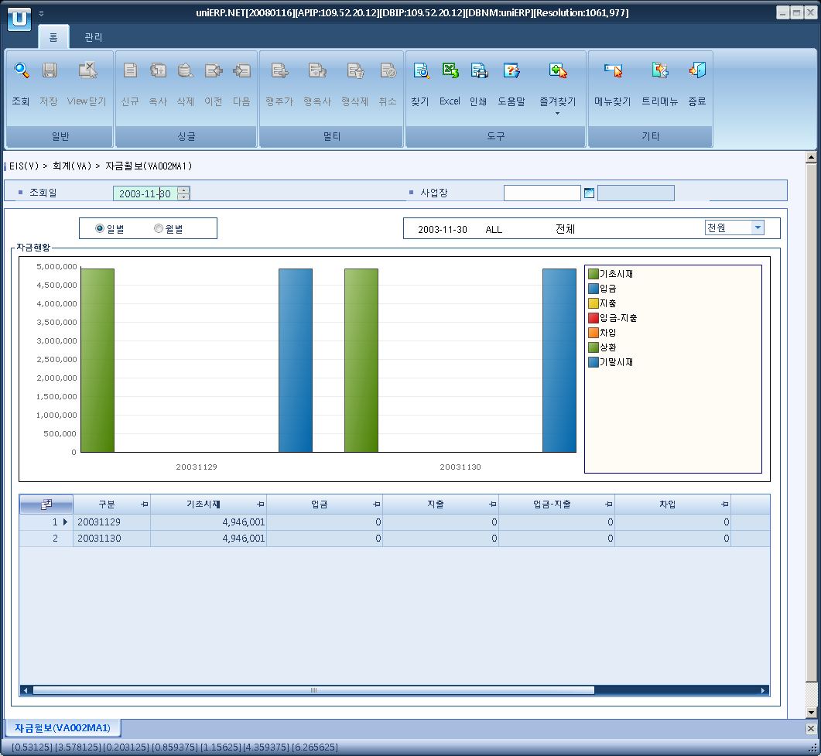

- Event flow
- Click Query button
- OnFncQuery -> DbQuery -> DataChange
- Display Unit combo change
- uniCombo1_ValueChanged -> DataChange

- SQL Statements
- Day status
SELECT VA002AT.YYYYMMDD,
VA002AT.BAS_AMT, VA002AT.RECEIPT_AMT, VA002AT.ISSUE_AMT, VA002AT.DIFF_AMT,
VA002AT.LOAN_AMT, VA002AT.REFUND_AMT, VA002AT.INV_AMT
FROM VA002AT
WHERE VA002AT.SP_ID = @strSpid

- monthly status
SELECT VA002BT.YYYYMM AS YYYYMMDD,
VA002BT.BAS_AMT, VA002BT.RECEIPT_AMT, VA002BT.ISSUE_AMT, VA002BT.DIFF_AMT,
VA002BT.LOAN_AMT, VA002BT.REFUND_AMT, VA002BT.INV_AMT
FROM VA002BT
WHERE VA002BT.SP_ID = @strSpid

